The Right Facts

Edition 1 – November 2016

By Your Name

Students are not learning the right facts

(Problem and Solution)

Many students are not learning the right things and as much as they need to. People/Teachers are doing their job but the people who make the curriculum (Not all the People) don’t really state the right facts. Sometimes they say that “Columbus discovered the America’s” but really the Native Americans did. Another problem is that sometimes the curriculum makes math units out of order. This truly is a serious problem.

Since this is only in some schools and not in every single school we can solve this problem easily. We can talk to experts I education and bring together a team of specialists so that the curriculum will be better than it already is there. We can think of what goes together and what the unit would be. We can think about the wording that goes into textbooks so students can understand the text better. Together we can make a difference in learning.

What Are PBL’s?

(Description)

By: Priyanka Kavdikar

PBL is project Base Learning. Doing PBL’s is a great way to get more and more creative. They can use anything to get a way to show people what they made. Students use technology these days and, with technology, they can mostly do anything. PBL’s can also be a way to learn something new. Like in a project of PBL you can be asked to research something you never knew. You can also have fun with PBL’s such as creating a product with arts and crafts.

PBL’s focus on a student’s learning goals. According to the article “What Is Project Base Learning” It says “Including standards-based content and skills such as critical thinking/problem solving.” PBL”s also help to collaborate, self-management, and time being. This project also includes things like challenging word problems and questions, a student’s choice, and reflecting. According to the article “What is Project Base Learning it says that “The project is framed by a meaningful problem to solve or a question to answer, at the appropriate level of challenge.”

PBL’s also include math tasks, reading tasks, and more. They give students learning and be creative. At the end of PBL’s they usually reflect and finally they can also share it with the world.

Technology in Classrooms and Normal Classrooms

(Compare Contrast)

By: Priyanka Kavdikar

Technology in classrooms and simple classrooms without technology are different in many ways. Such as one difference is that classrooms with technology is a way to get students more engaged in learning because students use phones, tablets, I-pads and more. However in normal classrooms students often get bored of reading from textbook and don’t feel part of the classroom. This is very bad for a student’s learning and then they don’t learn much either. But, when teachers teach with active boards students tend to put all their attention or focus into the technology that is being used. Scientists also said that ALL human beings look at the lighted part or anything that is moving.

Although that they are different they are also similar in ways too. Any way that teachers teach, with or without or technology, the students still learn a lot. They always learn something new and something interesting. For example the students in a classroom that have no technology still learn new things. Like if the topic was space and it was a new topic everyone would learn something interesting and something new. This catches everyone’s attention. Now suppose that the same teacher uses technology to teach the exact same thing to the students. Would they still learn something new? Yes because even though it catches their attention better either way they would still learn something new and interesting.

Another way that they are different is because with technology in the classroom teachers can assign the tasks to different and multiple. According to the article “5 Ways Technology in the Classroom is Changing Education” by Ashley wainwright it says that “Lessons can be customized to fit each student’s progress and learning style.” However a teacher without technology can only assign things to everyone and if a student cannot process it and needs more practice the teacher will still have to move on. Both are clearly similar and different.

The Right Facts

Title of Article

(Cause and Effect)

**Poverty** is a big thing and it effects education in many ways. Such as a child’s success in learning, and people don’t know about their health or wellbeing. They also don’t know much about their health or **wellbeing**. A lot of people can’t write or don’t have any writing or l**iteracy abilities.** Poverty effects education in so many ways they are countless and hard to explain

A child’s **succession** learning is very important to a lot of people because they like to master education. Poverty effects this because not having proper education can lead to one thing to another. For example if they don’t have proper education then many people are not generous enough to except them in jobs which can lead to not making money and having to have very less food**.**

Health and wellbeing are also another big thing that poverty effects. For instance if you don’t know what **diseases** spread quickly, or, you don’t know how to cure them it could get real serious and you could get infected very badly. According to the sight “Edutopia” it says “Poor nutrition can affect the rate of childhood” It can also effect normal abilities too.

Poverty also effects language and writing abilities in many ways too. First, they won’t be able to speak and/or write properly. This is bad because when they go to school they understand fewer words and don’t know what the teacher is saying. This also effects their reading ability to understand few words. It appears that poverty effects education in many ways.

How to Create Your Own PBL

(Chronological Order)

Do you want to make an educational PBL? Well let’s get started!

First, give your students a choice on what to research based on the unit that is going on or going to get started. Then relate it to the **curriculum** like putting questions in it. Let’s say this unit was **endangered animals**

Now ask them to pick a certain topic that they researched and in our case an endangered animal. After make a critical thinking question like “If this animal goes extinct what will happen?” How this is animal endangered? How can we help it?” and such questions.

Once they are done with that ask them to make a presentation that requires what they have done. Such as thinking questions and info about their topic.

Well if you were a teacher in need for an educational PBL and don’t know how to make one, now you do!

This is a picture of a school from the 1800’s

Picture

This is an open house school.

How education has changed in the past years.

Picture

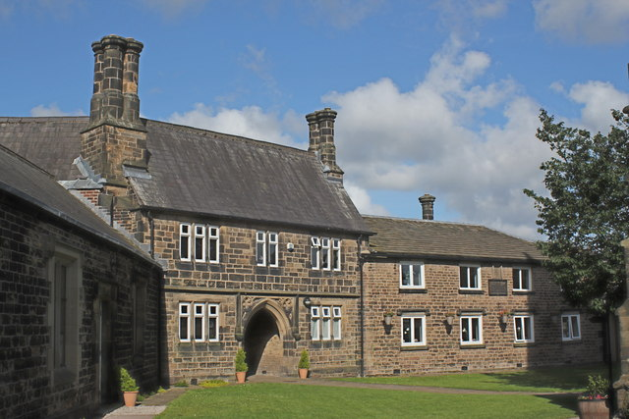

This is a chart on how many people go to school

Chart or Graph

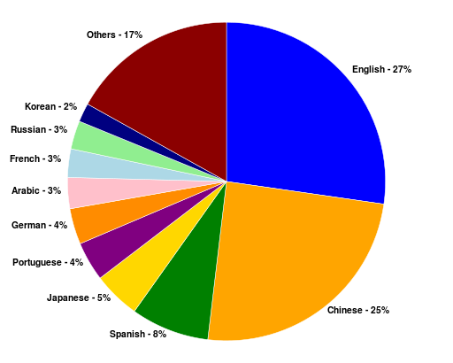

We Should Have School

(Opinion Essay)

By: Priyanka Kavdikar

Do you think we should have to go to a formalized school to learn? Some people think that we shouldn’t have school because you can do other activities. Other people think that school is important. In school they give you facts about the past and these can make your brain more interested about learning. When you become interested in learning you know more about the topic to get better grades. You could even become a world famous scientist who is known to everybody for finding more about things that are even more in the past that we never imagined. Of course that this can happen but only if you go to school. I think that the positive points about having to go school are because the topics math, reading, social studies, and science are all used in our everyday life, we have chance to meet other students and it’s a good way for you to get more interested in in a lot of things.

We should have school because math, reading social studies and science are all used in our everyday word. For example, when you go to the store and you need to buy something, you can easily read the labels, get it for a reasonable price and check to see if the quality is good. Do you see how just a simple thing like buying something at the store caused you to use the skills reading, math, and science? Clearly tougher things will defiantly all these skills in a higher level. According to the sight List Surge it says “All skills are used in the everyday world no matter where you are and what you are doing.” This proves that we should have school because we use these skills every day.

It is important for us to have school because it gives us a chance to meet other students and make new friends. This is good because the more friends you have the less chance you have of being bullied. According to scientists they say “Having more friends makes people have e happier life. This is because you can count on your friends and you can tell them your feelings. Of course you can make friends in your neighborhood but if you want a happier life then make friends everywhere like in school, you should have a formalized school.

Finally we should go to school because you can get interested in things. Now you might think how this is important. Well, let me tell you it’s important because this improves your general knowledge and when you have more general knowledge you can get into higher powered and money jobs. According to scientists they say “Getting interested in things leads to jobs.” You could also spend time researching what you like or what you are interested in instead of being bored when you have nothing to do. This proves getting interested ion things is a big part of your life.

In conclusion I think we should have school because math, reading, science, and social studies are all used in our everyday life, we have a chance to meet other students, and you can get interested in a lot of things. Hopefully by now you think we should have a formalized school.

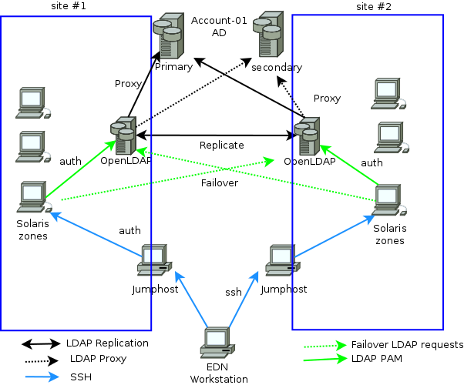

1. What is an endangered animal?

2. What is an open schoolhouse?

3. What is your wellbeing?

4. What is a curriculum?

5. What is poverty?

6. What are diseases?

7. What is succession in something?

8. Does Poverty effect their learning?

9. How does Poverty effect their learning?

10. How are classrooms with technology similar to classrooms without technology?

This is a diagram of an open schoolhouse

**Glossary**

**Curriculum- The curriculum is every unit and topic they have for you in a school year**

**Diseases- Diseases are what are you get if you are sick**

**Endangered Animals- Animals that are endangered, have few of them and maybe will go extinct**

L**iteracy- This is writing**

**Poverty- this when people don’t have a house, food etc.**

**Succession- This is when you accomplish or succeed in doing something**

**Wellbeing- Wellbeing means how your body is**