Hurricanes and Thunderstorms
(Compare and contrast)
There are many differences in thunderstorms and hurricanes. First hurricanes form in the sea. Thunderstorms are made by cumulonimbus clouds. Another difference is that is that a hurricane has a eye and thunderstorms are often accomanied by hail. Hurricanes do a lot of damage as when thunderstorms actually play a important role in earth’s hydrologic cycle.
There are also many similaraties in hurrincanes and thundrestorms are that they both have very dramatic results. Another similaratie is that they can both bring small tornados. The next similaritie is that they both bring lots of rain.The final similaritie is that they can both bring what is called “ red sprites” and “blue spites” which is a optical phemonia that sometimes occur during hurricanes and thunderstorms.

Storms
By Isabel Liu
November 27, 2016

Which one is deadlier, tornados or Hurricanes ?
(Opinion)
Tornado and hurricanes are both very dangerous. Some people think that hurricanes are more dangerous than tornados. However, other people think that tornados are more dangerous than hurricanes. I think that tornados are more dangerous than hurricanes because one, tornados are very fast, Two, tornados are very hard to study, finally, tornados are highly dangerous.
The first reason on why I think tornados are deadly is because tornados move very fast destroying everything in its path. Even a funnel cloud can be dangerous because it can reach the ground very quickly and form a tornado.
The second reason is because tornados are hard to study. Scientists know very little about this subject of nature. Because scientists know so little about it makes a tornado very dangerous. A tornado is hard to study because all the contents in a tornado is very complicated. Tornados are also hard to predict.
Finally, tornado are highly dangerous. Even though most tornados start as a funnel cloud, but sometimes a tornado starts with a mesocyclone. Mesocyclones can form some of the deadliest tornados. One deadly tornado is called “The Joplin tornado”
That is why I believe that tornados are more dangerous than hurricanes. Now I hope that you can all agree that tornados are more deadly that hurricanes. Hopefully you can see that one, tornados are very fast. Two, tornados are very hard to study. Finally tornados are highly dangerous.

are more

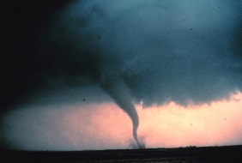
How tornados and hurricanes form
(order/sequence)
This how a hurricane is formed. First moist air rises from the water . Then the cooler air starts to warm. In this cycle giant stormclouds start to form. After that the giant stormclouds start to rotate. If there is enough warm water this cycle keeps going. Finally the wind speed increases and finally a hurricane is formed.
Do you know how a tornado is formed? First cool dry air and warm moist air meet. Then they create a instability in the atmosphere. Because of the instability it cause change in wind direction, an increase in wind speed and height, and it creates a horizontal spinning affect. After that the rising airupdraft tilts and the rotating air turn from horizontal to verticle.Finally the area rotation now 2-6 miles wide extends through much of the storm.

[Sidebars are great for calling out important points from your text or adding additional info for quick reference, such as a schedule.
They are typically placed on the left, right, top or bottom of the page. But you can easily drag them to any position you prefer.
When you’re ready to add your content, just click here and start typing.]

Wayward and Leeward
(cause and affect)
Do you know how mountains affect climate? Mountains have two sides they are called wayward and leeward. When there precipitation is precipitation the cloud moves up the mountain and when it gets to the top stops. That is why leeward does not get any rain and the climate stays dry.

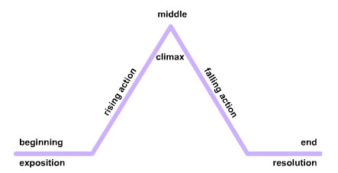
This is a diagram of wayward and leeward
Global warming
(cause and affect)
How much do recycle? Global warming can be a problem but we can make a difference. Global warming are caused by humans. To keep global warming from happening you might want to try carpooling. When you can carpool. When you carpool it will help reduce the amount of fossil fuels going into the atmosphere. Some other suggestions are planting trees and recycling.
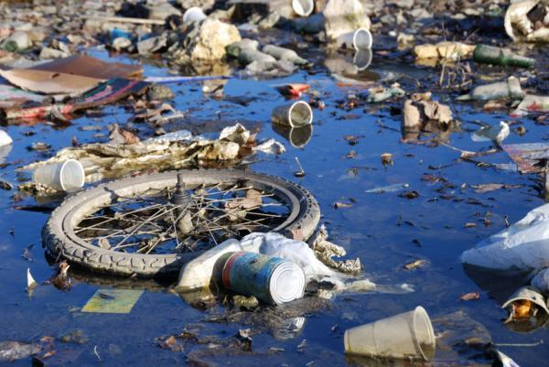
As you see here this area is very polluted and caused by human activities.

Mini quiz
When do blue and red sprites occur?
_______________________________________________

How much do scientists know about tornados?
_______________________________________________
List the first step of how a hurricane is formed
_______________________________________________
El Nino and La Nina
Description
Have you ever heard of El Nino? El Nino is a pattern in the
weather pattern in the Pacific ocean. The El Nino climate conditions occur every few years, El Nino is also not predictable. Did you know that El Nino is Spanish for” Little boy”? In a normal year the warmest water is in the far western pacific, this forms thunderstorms. In a El Nino year, the warmest water move eastward across the pacific. When this happens they disrupt jet streams, changing the weather pattern.

What if El Nino had a opposite? Well the the answer to that is yes, there is a opposite. The opposite is known as La Nina. During La Nina the same area along the equator gets colder. La Nina cycles generally creates more active hurricane season in the atlantic. In the united states, La Nina is expected to to bring above normal tempature throughout most of the southeast during winter months and La Nina is also expected to affect rainfall.

Glossary
Atmosphere – the envelope of gases surrounding earth or another planet

Cycle – a series of events that are regularly repeated in the same order

Predictable – able to be predicted

Disrupt – drastically alter or destroy the structure of (something)

Jet streams – a narrow variable band of very strong predominantly western air currents encircling the globe several miles above the earth

Temperature – the degree or insensity of heat present in a substance or object

