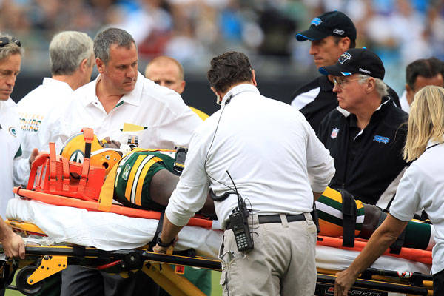­­­an

This is what can happen if you get tackled too hard.

(Problem and Solution)

Injuries in Football

Do you know what tackling is? It is where you try to bring down somebody. There is a big problem about that in football. It is not good to players.

The problem is that tackling can hurt or injure players. This is not good, because if a football player gets injured they can’t play for a few games. Sometimes they can’t even play until the season is over! They can solve this problem by trying not to injure or hurt any players. The football players should also not tackle each other way to hard so they can’t get injured.

Do you think they should tackle each other hard? In my opinion I think that they shouldn’t. That is why I think they shouldn’t tackle each other hard.

(Chronological order)

How to make it to the NFL

Have you ever wanted to be a football player in the NFL? The NFL stands for ‘‘The National Football League’’. Being a football player is really hard especially going to the NFL. Even if you try to make it to a high school football team it is hard. You have to be a very good football player to play football.

First, you need to get an athletic scholarship from high school to start playing high school football. You also have to get good grades in your high school to make it to a good team. Next, if you are good enough you play college football. After that, you have to be a very good football player to make it to the NFL draft. The NFL draft is where they pick you to which NFL team you are going to play on. Finally, you make it to the NFL and go to the team where they told you to go to.

This is how you make it to the NFL. If you wanted to go to the NFL this tells you how to make it to the NFL.

NFL Football

Edition 1 – November 2016

By Ayham Ibrahim

How to Play Football

(Description)

Do you know how to play football? Football is a very popular sport in America. You need to know the rules about football and you need to know how to play football.

In football offense is where you have the ball trying to score, defense is where you try to get the ball from the offense. In football you need to where shoulder pads, a helmet, and shoes that are called cleats so they won’t slip while they are running. In football a team has to kick the ball while the other team is trying to score a touchdown. The other team can pass the ball, run the ball, or kick a field goal. On defense they try to intercept the ball when the team on offense passes the ball, the team on defense also tries to make the team on offense fumble when the team on offense is running the ball. After the team on offense scores a touchdown they kick a field goal for one more point or you do a 2 point conversion for 2 points.

If you did not know how to play football, well now you do. You should play football, it is a fun sport.

NFL Football

Too many Players on a Team

(Cause and Effect)

Do you know how many players can be on a NFL football team? There are supposed to be 53 players on a football team. It is not fair, because some players do not get as much playing time as others. The players who can’t play as much as the others probably don’t like it that way.

If other players do not get as much time playing than the others, that is not good. If that player does not play a lot the coach might want to trade that player to a different team. This can also affect them, because if they do not play as much than they will not make a lot of money playing football. Sometimes, the only time where they can play is when a player gets injured or hurt. But they make around one million dollars a year! Players who do play a lot make around two million dollars.

Do you think that is fair? I do not think it is fair for players who do not play as much. I think that all players should all have the same amount of time played each and every game. I think that there should be about 40 players on each team not 53. Do you agree with me?

(Opinion essay)

The Super Bowl is the Best PART of Football

Do you know what the Super Bowl is? The Super Bowl is the championship for NFL football. In my opinion I think that the Super Bowl is the best part in NFL football. This is true, because everyone wants to see which team is going to win the Super Bowl. People all around the world are watching the Super Bowl.

Everyone wants to see the Super Bowl. They want to see the Super Bowl, because they want to see which team will win and which football player is going to get the trophy. Especially, when your favorite NFL team is playing in the Super Bowl you would really want to see if your favorite NFL team is going to win the Super Bowl. If your football team loses in the Super Bowl that is not good, because you have to wait a few more months before you play again.

People all around the world want to watch the Super Bowl, because a whole bunch of people in the world like football. In many different countries besides America people also want to watch the Super Bowl. In, 2015 the New England Patriots were against the Seattle Seahawks and more than 168 million people watched the game! If you want to watch the Super Bowl you might not get in, because the tickets might be sold out! Also, the tickets are very expensive.

If you want to play in the Super Bowl your team has to be a very good team in the NFL. The NFL managers pick the two best teams in the NFL to make it to the Super Bowl. Before your team plays in the Super Bowl you have to win every single game in the playoffs. You might have to be undefeated to play in the Super Bowl.

Do you think that the Super Bowl is the best part in football? By know you should think that the Super Bowl is the best part in football. I think that it is the best part in NFL football.

NFL Football

er

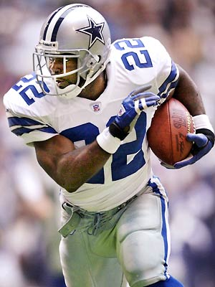

Emmitt Smith or Bo Jackson

(Compare & Contrast)

Have you ever heard of one of the two best running backs in football history? Emmitt Smith and Bo Jackson are 2 very good NFL football players. One of them has to be better than the other.

Bo Jackson’s rushing yards and Emmitt Smith both have a different amount of rushing yards. Jackson has 2,782 yards in his whole football career, but Smith has 18,355 yards in his whole football career. Jackson and Smith played on different teams. Smith played on the Dallas Cowboys and he also played on the Arizona Cardinals. Jackson played only for the Oakland Raiders, he never played for 2 years. Smith and Jackson were both running backs in the NFL. Smith played for 15 years in football and Jackson played football for only 4 years.

I would say that Emmitt Smith is better, because he has more rushing yards and more touchdowns. They are both very good players, who do you think is better?

Who’s Better?

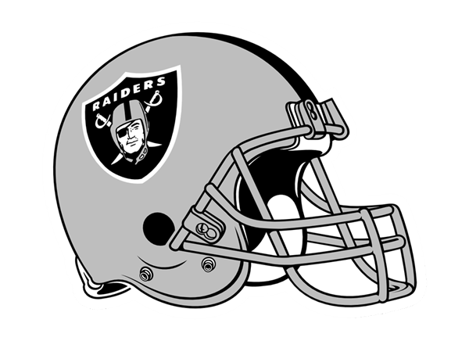

This is the team Bo Jackson played on. They are called the Oakland Raiders.

This is a picture of Emmitt Smith.

g b n s k h c d u t c s o f h o p q w e r t y u I o p a s d f g h j k l z x c v o b n m q w e r t f l f s y u I o p a s d f g h j k l o x c v b n m q w e r u a g I o p a s d f g h j k l t x c v b n m q w e r p y u I o p q a z w s x e d b c r f v t g b y h n e e k m d h g f h x j x f b j b a g f f s j d u s l n d r r e k g j b x h g f h f f j l h t o u c h d o w n b b d j d f g j d x y d u d c I u u j f t v f d g d o b g j f j f y l k b x s g y o i f h h g d x g j g j f w f f g s t h g y d p o s i t i o n g s g d h f f t d g l

Words

Football NFL (will be lower case) (will be lower case) (will be lower case) Super Bowl (will be lower case) Touchdown Position

Jackson

The Super Bowl was made.ftt

1967

Emmitt Smith started playing NFL football.

1990

Bo Jackson started playing football.

1987

1920

The NFL was made.

NFL Football

|  |  |  |  |  |  |  |  |  |  |
| --- | --- | --- | --- | --- | --- | --- | --- | --- | --- |
|  |  |  |  |  |  |  |  |  |  |
|  |  |  |  |  |  |  |  |  |  |
|  |  |  |  |  |  |  |  |  |  |
|  |  |  |  |  |  |  |  |  |  |
|  |  |  |  |  |  |  |  |  |  |
|  |  |  |  |  |  |  |  |  |  |
|  |  |  |  |  |  |  |  |  |  |
|  |  |  |  |  |  |  |  |  |  |
| ggg |  |  |  |  |  |  |  |  |  |
|  |  |  |  |  |  |  |  |  |  |
|  |  |  |  |  |  |  |  |  |  |
|  |  |  |  |  |  |  |  |  |  |
|  |  |  |  |  |  |  |  |  |  |
|  |  |  |  |  |  |  |  |  |  |
|  |  |  |  |  |  |  |  |  |  |
|  |  |  |  |  |  |  |  |  |  |

Glossary

NFL The NFL stands for the National Football League.

Manager The boss of something important.

Injure To get hurt very badly.

Super Bowl The championship for NFL football

Draft Where you get picked to something.