Week 1  Oct 19-23 | PBL Accountability  - Home Project  - Museum Display
Resources | BrainPopJr - Cherokee Safari - Native American Life KidRex
Informational Reading Standards |  | Content Standards | Essential Question/I Can…  Anchor Chart Creation | Modeled / Anchor Text
ELAGSE2RI2: Identify the main topic of a multi-paragraph text as well as the focus of specific paragraphs within the text.  ELAGSE2RI5: Know and use various text features (e.g., captions, bold print, subheadings, glossaries, indexes, electronic menus, icons) to locate key facts or information in a text efficiently. |  | SS2H2 The student will describe the Georgia Creek and Cherokee cultures of the past in terms of tools, clothing, homes, ways of making a living, and accomplishments.  a. Describe the regions in Georgia where the Creeks and Cherokees lived and how the people used their local resources.  b. Compare and contrast the Georgia Creek and Cherokee cultures of the past to Georgians today.  SS2G2 The student will describe the cultural and geographic systems associated with Georgia’s Creeks and Cherokees.  e. Describe how the region in which these historic figures lived affected their lives and compare these regions to the region in which the students live.  SS2E3 The student will explain that people usually use money to obtain the goods and services they want and explain how money makes trade easier than barter.  **We aren’t assessing this standard until next unit, but since the Native Americans bartered, this standard will be touched on in this unit. | How were the decisions made by the Creek and Cherokee connected to where they lived?  How did the Creek and Cherokee make life better for people in GA?  How was daily life for the Creek and Cherokee the same / different for the lives of people today? | Social Studies Textbook  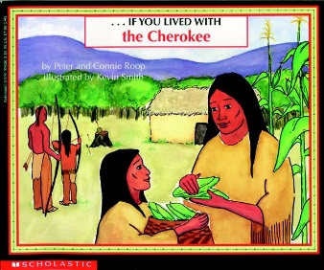  (PTA provided book)  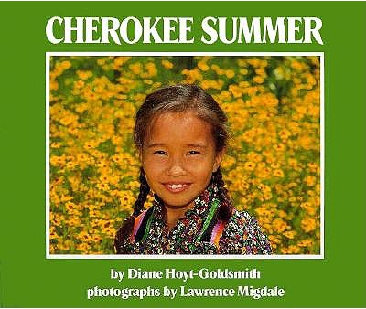

Date |  | Mini Lesson | Assessment
October | 19 | Teacher read The Creek pgs 30-35 in the SS textbook aloud with the Promethean. Point out text features, captions, and pictures that help understanding.  Briefly discuss Home Project and send home parent letter. | None – Day 1
 | 20 | Students re-read The Creek pgs 30-35 in the SS textbook independently, with computer assistance, or with a partner. Students complete the organizer for a Reading & SS CW Grade.  Small group – discuss pg 36-37 in the SS textbook, and how pictures & diagrams support understanding | Reading & SS CW Grade
 | 21 | Teacher read The Cherokee pgs 50-55 in the SS textbook aloud with the Promethean. Point out text features, captions, and pictures that help understanding.  Project Decision due today for a Reading HW Grade. | Reading  HW Grade
 | 22 | Students re-read The Cherokee pgs 50-55 in the SS textbook independently, with computer assistance, or with a partner. Students complete the organizer for a Reading & SS CW Grade. | Reading & SS CW Grade
 | 23 | Bartering Activity – Students will come up with something they can use to barter and trade for in the classroom. Use activity sheet with directions, if needed. (whole group OR small group) SS CW Grade | SS CW Grade

Week 2  Oct 26-30 |  | PBL Accountability  - Home Project  - Museum Display
Resources |  | Folktales Cheat Sheet
Literary  Reading Standards |  |  | Content Standards | Essential Question/I Can…  Anchor Chart Creation | Modeled/ Anchor Text
ELAGSE2RL2: Recount stories, including fables and folktales from diverse cultures, and determine their central message, lesson, or moral.  ELAGSE2RL5: Describe the overall structure of a story including describing how the beginning introduces the story, the middle provides major events and challenges, and the ending concludes the action.  ELAGSE2RL9: Compare and contrast two or more versions of the same story (e.g., Cinderella stories) by different authors or from different cultures. |  |  | SS2H2 The student will describe the Georgia Creek and Cherokee cultures of the past in terms of tools, clothing, homes, ways of making a living, and accomplishments.  a. Describe the regions in Georgia where the Creeks and Cherokees lived and how the people used their local resources.  b. Compare and contrast the Georgia Creek and Cherokee cultures of the past to Georgians today.  SS2G2 The student will describe the cultural and geographic systems associated with Georgia’s Creeks and Cherokees.  e. Describe how the region in which these historic figures lived affected their lives and compare these regions to the region in which the students live.  SS2E3 The student will explain that people usually use money to obtain the goods and services they want and explain how money makes trade easier than barter.  **We aren’t assessing this standard until next unit, but since the Native Americans bartered, this standard will be touched on in this unit. | How were the decisions made by the Creek and Cherokee connected to where they lived?  How did the Creek and Cherokee make life better for people in GA?  How was daily life for the Creek and Cherokee the same / different for the lives of people today? | Cherokee Summer by: Diane Hoyt-Goldsmith  The Story of the Milky Way: A Cherokee Tale by: Joseph Bruchac  How Turtle’s Back Was Cracked: A Traditional Cherokee Tale by: Gayle Ross  The First Strawberries: A Cherokee Story by: Joseph Bruchac  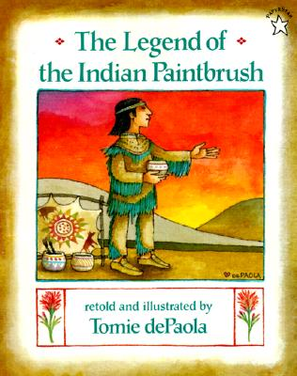
Date |  | Mini Lesson |  |  |  | Assessment
October | 26 | Introduce Creek and Cherokee PBL – begin working on this project, due next week.
 | 27 | Read aloud modern fairy tale (Cinderella), discuss character traits, and the central message, lesson, or moral. (Moral – kindness is rewarded, treat others how you want to be treated)  Project Organizer due today for a Reading HW Grade.  Work on Creek and Cherokee PBL |  |  |  | Reading HW Grade
 | 28 | Read Aloud Native American Cinderella – Rough Faced Girl, discuss character traits, and the central message, lesson, or moral. (Moral – kindness is rewarded, treat other how you want to be treated)  Work on Creek and Cherokee PBL
 | 29 | Small Groups – Students will create a compare and contrast Venn Diagram comparing Cinderella to The Rough Faced Girl. Reading CW grade  ELAGSE2RL9: Compare and contrast two or more versions of the same story (e.g., Cinderella stories) by different authors or from different cultures.  Work on Creek and Cherokee PBL |  |  |  | Reading CW Grade
 | 30 | Go to KidRex do a search for Native American Folk Tales. In a small group OR with a partner read and discuss a few of these folktales. Decide what you would like to include as a part of your PBL (museum) project. Discuss the central message, lesson, or moral that you will share.  Work on Creek and Cherokee PBL

Week 3  Nov 2-4 | PBL Accountability  - Home Project  - Museum Display
Resources | Folktales Cheat Sheet
Literary  Reading Standards |  | Content Standards | Essential Question/I Can…  Anchor Chart Creation | Modeled/ Anchor Text
ELAGSE2RL2: Recount stories, including fables and folktales from diverse cultures, and determine their central message, lesson, or moral.  ELAGSE2RL5: Describe the overall structure of a story including describing how the beginning introduces the story, the middle provides major events and challenges, and the ending concludes the action.  ELAGSE2RL9: Compare and contrast two or more versions of the same story (e.g., Cinderella stories) by different authors or from different cultures. |  | SS2H2 The student will describe the Georgia Creek and Cherokee cultures of the past in terms of tools, clothing, homes, ways of making a living, and accomplishments.  a. Describe the regions in Georgia where the Creeks and Cherokees lived and how the people used their local resources.  b. Compare and contrast the Georgia Creek and Cherokee cultures of the past to Georgians today.  SS2G2 The student will describe the cultural and geographic systems associated with Georgia’s Creeks and Cherokees.  e. Describe how the region in which these historic figures lived affected their lives and compare these regions to the region in which the students live.  SS2E3 The student will explain that people usually use money to obtain the goods and services they want and explain how money makes trade easier than barter.  **We aren’t assessing this standard until next unit, but since the Native Americans bartered, this standard will be touched on in this unit. | How were the decisions made by the Creek and Cherokee connected to where they lived?  How did the Creek and Cherokee make life better for people in GA?  How was daily life for the Creek and Cherokee the same / different for the lives of people today? | 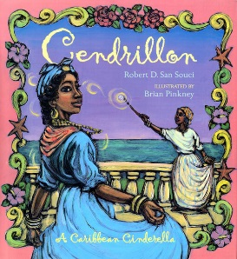  (PTA provided book)

Date |  | Mini Lesson | Assessment
November | 2 | Presentation of Home Project due by today for a Language Arts CW grade. | Language Arts CW Grade
 | 3 | Project(s) Completion Time – Students will turn in and present all projects (in class PBL project & at home project). SS SA | SS (Test) SA
 | 4 | End of Unit Traditional Assessment – SS SA | SS (Test) SA
 | 5 | Next Unit is Science (Matter)
 | 6 | Matter Unit

