Playful Dogs

(Problem and Solution)

Has your dog ever wanted to play with you but you were busy? That has happened to me. It was a little annoying. When I was working my dog kept jumping on my leg. I thought to myself. I had to do something. I couldn’t let him annoy me. My mom would get mad. I went to get some food or bone. I kept him busy on his bone and when I finished my homework, I went outside to play with him. The problem is the dog wants to play and the solution is giving it something to eat.

Chihuahua’s or Labrador’s

(Compare and Contrast)

Would you rather get a Labrador or a Chihuahua? I would rather get a Labrador than a Chihuahua. Chihuahua’s are a little bit too crazy. Labrador’s are huge but not as crazy as Chihuahua’s. Labrador’s barks are very loud. Chihuahua’s bark isn’t as loud as a Labrador. The weird thing is when Chihuahua’s get too crazy they wet a little bit.

Dogs

Edition 1 – November 2016

By Kenny

DOGS

Chihuahuas

*(*Description*)*

Chihuahuas are a type of dog. Chihuahuas may bark, go number 1 on the carpet, go number 2 on the carpet, etc. When they get too excited. Dog’s feces can tell you a lot about a dog’s health. Most Chihuahuas have fur. A typical Chihuahua weighs 3 to 6 pounds.

Dogs, Dogs, Dogs

*(Cause and Effect)*

Do you what might happen if somebody comes in your house and you just have a CRAZY DOG? There is multiple things that might happen. But let me tell you what my dog will do, yes I am calling my dog crazy. Whenever I come in my house my dog runs toward me and starts jumping on me. I pet him and then I hear ”ssssss”. I look on the floor and I see pee! That might happen when somebody goes in your house. The cause is the dog pees on the floor. The effect is I have to clean it.

Steps to Walking Dogs

(Chronological Order)

Do you know how to walk dogs? I do. Let me tell you how? First you need a leash and a collar. You hook the leash on to the collars ring if it has one. You take the dog outside and walk with it until it has done its job.

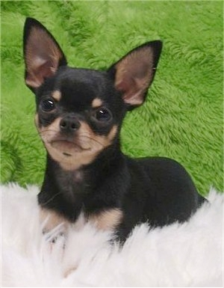

This is a cute chihuahua

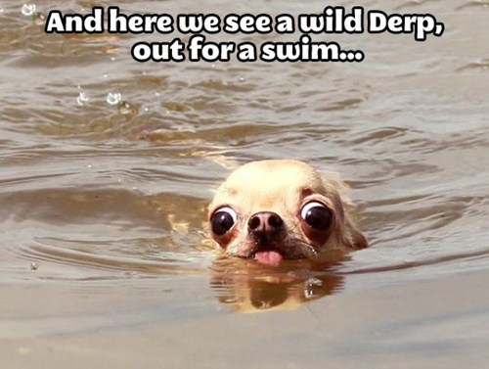

Wild derp…

Timeline

Dogs

(Opinion Essay)

Do you like dogs? I do. Some people like dogs because they might think that they are good companions. Some people think they are annoying. I think they are good to keep as a pet because, the dog can guard my house (guard dog), if I was blind it could take me to places I need to go, and they are good companions for the dark.

Some people like them. The dog can guard the house. If a robber comes in the house and the house has a guard dog then the dog can make the robber go away. Or attack them. It would be easier to call the police.

Some people don’t like them. The dog might pee and poo everywhere. They are sometimes annoying. They have to feed the dog, and walk the dog. They would probably have an ☹ attitude.

I like them. They are good companions while you are in the dark. I won’t get scared. My dog will make me feel a little bit☺. I would carry him/her all the way till I find light.

Did you change your mind? This is why they are good to keep as a pet because, the dog can guard the house, if I was blind and it can lead me to the place I need to go, and the are good companions for the dark. I am trying to make you like dogs. Just try to remember that they are loyal but they can be annoying. This is why I like dogs when they are not annoying

Glossary

Glossary

Leash: *noun* it is a thing that is sometimes used for taking the dog outside. You get it at a pet store. It is a line with a hook.

Collar: *noun*  it is a thing that is used for taking the dog outside. It has information on it so if the dog got lost the person who finds it looks at the address then the dog can arrive home not getting hurt. It is circlish.

Annoying: *adjective* Annoying means bothering. For example, the dog is so annoying. When somebody is annoying they are not letting you focus on whatever you are doing