Name: _______________________________
____
30
The Creek
Directions: Use your Social Studies textbook to complete this graphic organizer. Look in the index on page R35 to find out where you would collect information about the Creek American Indians.

What pages can you go to collect this information? _________________________

Fill in the organizer with information about the Creek American Indians by looking on pages 30-35 in your Social Studies textbook.
Heading:
Sub-heading 1:
Main Idea | Details
 | 1.
 | 2.

What is the bold faced word in this section? ____________________________
What is the glossary definition for this bold faced word? ________________________________________________________________________________________________________
____________________________________________________
Heading:
Sub-heading 2:
Main Idea | Details
 | 1.
 | 2.

What is the bold faced word in this section? ____________________________
What is the glossary definition for this bold faced word? ________________________________________________________________________________________________________
____________________________________________________
Look at the map on page 31. Read the caption. What does the map show? __________________________________________
________________________________________________________________________________________________________
Draw in where the Creeks lived within Georgia.
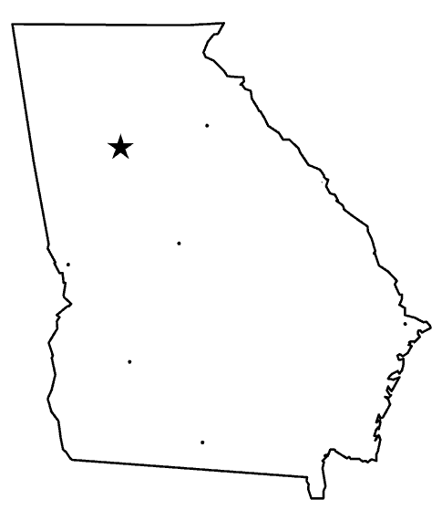
Heading:
Sub-heading 3:
Main Idea | Details
 | 1.
 | 2.

Look at the pictures on page 32. Read the caption. What do the pictures show? _______________________________________
________________________________________________________________________________________________________

How does the photograph and the caption help you to understand how the Creeks were similar to us today?
____________________________________________________
____________________________________________________________________________________________________________________________________________________________
Heading:
Sub-heading 4:
Main Idea | Details
 | 1.
 | 2.
Look at the picture on page 33. Read the caption. What does the picture show? _____________________________________
________________________________________________________________________________________________________

How does the photograph and the caption help you to
understand how the Creeks were similar to us today? ____________________________________________________
____________________________________________________
____________________________________________________
Heading:
Sub-heading 5:
Main Idea | Details
 | 1.
 | 2.

Look at the pictures on page 34 and 35. Read the captions. What do the photographs show? ________________________
________________________________________________________________________________________________________
____________________________________________________

Heading:
Sub-heading 6:
Main Idea | Details
 | 1.
 | 2.

Use other books / websites to find other interesting details.
Book / Resource | Interesting Fact

