Name: _______________________________
____
30
The Cherokee
Directions: Use your Social Studies textbook to complete this graphic organizer. Look in the index on page R35 to find out where you would collect information about the Creek American Indians.

What pages can you go to collect this information? _________________________

Fill in the organizer with information about the Cherokee American Indians by looking on pages 50-55 in your Social Studies textbook.
Heading:
Sub-heading 1:
Main Idea | Details
 | 1.
 | 2.

What is the bold faced word in this section? ____________________________
What is the glossary definition for mountain? ________________________________________________________________________________________________________
____________________________________________________

What is the glossary definition for valley? ________________________________________________________________________________________________________
____________________________________________________

Heading:
Sub-heading 2:
Main Idea | Details
 | 1.
 | 2.
Look at the map on page 51. Read the caption. What does the map show? __________________________________________
________________________________________________________________________________________________________
Draw in where the Cherokees lived within Georgia.
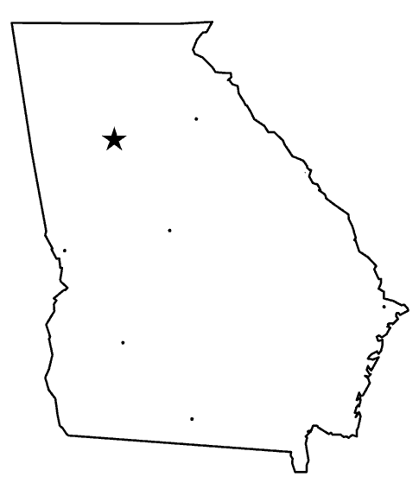
Heading:
Sub-heading 3:
Main Idea | Details
 | 1.
 | 2.
Look at the map on page 51 Read the caption. What does the map show? __________________________________________
________________________________________________________________________________________________________

How does the map and the caption help you to understand where the Cherokee lived? _____________________________
____________________________________________________________________________________________________________________________________________________________
Heading:
Sub-heading 4:
Main Idea | Details
 | 1.
 | 2.
Look at diagram on page 52. Read the caption. What does this diagram show? _______________________________________
________________________________________________________________________________________________________

How are the Cherokee homes similar to and different from the Creek homes?
Similar | Different

Heading:
Sub-heading 5:
Main Idea | Details
 | 1.
 | 2.

Look at the pictures on page 53. Read the captions. What do the photographs show? ________________________________
________________________________________________________________________________________________________
____________________________________________________

Heading:
Sub-heading 6:
Main Idea | Photographs and Captions
 | How do the captions help you understand each photograph better?
 | 1.
 | 2.

Use other books / websites to find other interesting details.
Book / Resource | Interesting Fact

